Weekly Reading Homework
Student Name: ________________________

Day of the Week | Assignment | Quick Check
Monday | I read a book for 20 minutes.  I worked on Lexia for 20 minutes.  Parent Signature | Write down three words or things you learned:  - _______________________  - _______________________  - _______________________
Tuesday | I read a book for 20 minutes.  I worked on Lexia for 20 minutes.  Parent Signature | Write down one thing for your reading teacher to help you with.  - _______________________
Wednesday | I read a book for 20 minutes.  I worked on Lexia for 20 minutes.  Parent Signature | What time did you start? ___________  What did the clock look like when you finished?  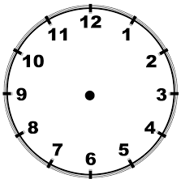
Thursday | On the back of this page, write 5 sentences telling about the main idea of a story you read this week. | Remember to check for CUPS.  C – Capitalization  U – Understanding  P – Punctuation  S – Spelling

Thursday Night Summary

Main Idea: Write your sentences telling what one story from your week (either Lexia or your book) was mostly about. You can start with this sentence starter:

The story _____________ was mostly about ___________________.

________________________________________________________________________________________________________________________________________________________________________________________________________________________________________________________________________________________________________________________________________________________________________________________________________________________________________________________________________________________________________________________________________
____________________________________________________________________________________________________________________________________________________________________________________________________________________________________________________________________

Ask yourself these questions:
Did I use my own words?
Did I remember CUPS?
Did I write neatly?
Does my writing make sense?

