Monday | Tuesday | Wednesday | Thursday | Friday
Reading | Reading | Reading | Reading | Check Friday Folder. Send back any papers and the blue folder on Monday!  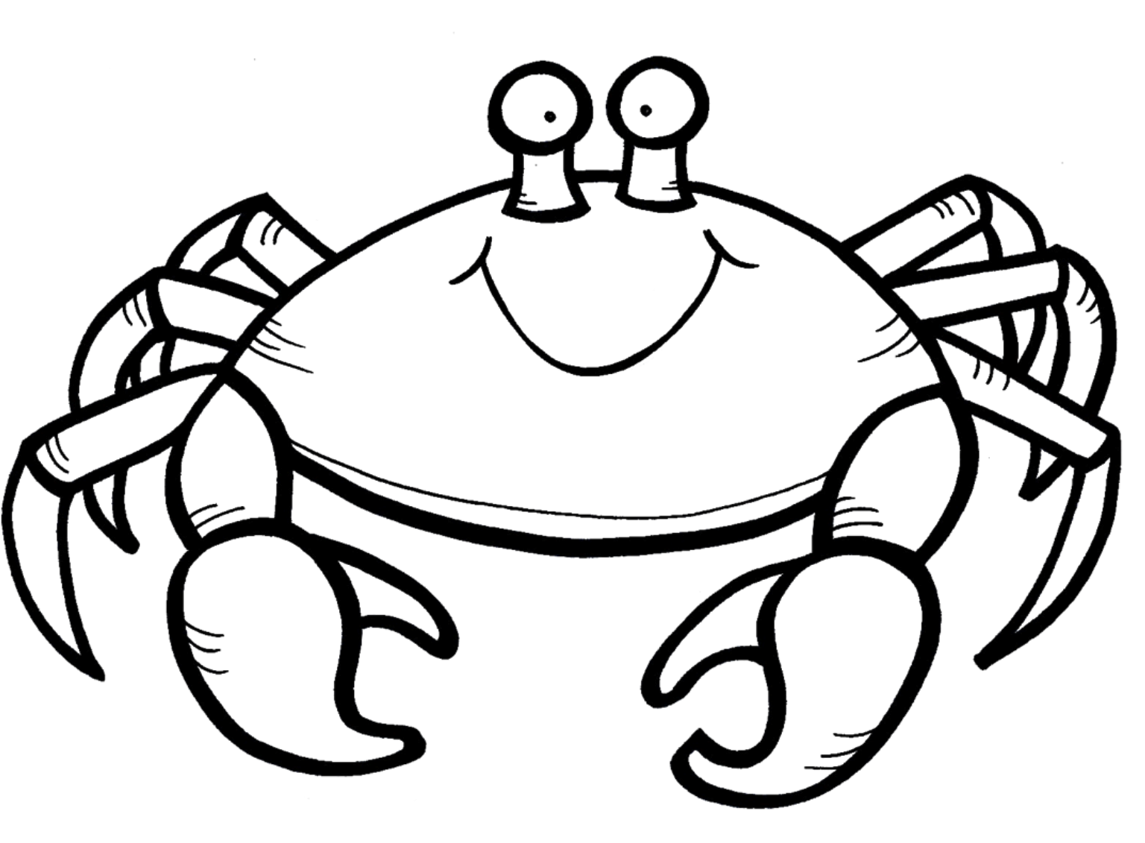
Math | Math | Math | Math
Spelling  3x each | Spelling  ABC Order | Spelling  Spelling Sentences | Spelling  Practice Test with grownup signature
Vocabulary  Write Definitions | Vocabulary  Vocab Sentences | Vocabulary  Synonyms and Antonyms | Vocabulary  Draw Pictures
Other | Other | Other | Other
Homework Agenda
Missing Spelling or Reading? Check out our Google Classroom: https://classroom.google.com

